Retest: Ancient China

Multiple Choice:Select the letter that best supports the question and fill in that bubble on your answer sheet.

1. Which of the following would **NOT** be a reform made by the Tang Dynasty to help with the reunification of China? (7.2)

* 1. Civil service exam
  2. Land reform for peasants
  3. Invention of gun powder
  4. Brought about peace & order in China

1. Why were people so willing to convert to Buddhism in ancient China? (7.2)
   1. It created peace by promising an end to suffering.
   2. It healed sickness.
   3. It made people rich.
   4. It was forced on people by governments.
2. How did the ideas of Buddhism spread through ancient China? (7.2)
   1. Military conquests
   2. Merchants on the Silk Road
   3. Turkish Nomads
   4. Mercenaries took it with them as they fought

In the chaos that reigned after the fall of the Han dynasty in 220 C.E., no one knew if a unified China would ever again be possible. Warring clans, political murders, and foreign invaders characterized the next four centuries until the Tang Dynasty reigned.

Use the passage below to answer question 4.

1. How would you characterize life before the Tang Dynasty and what words help you make your choice? (7.2)
   1. Peaceful: unified, possible, forgive
   2. Organized: unified, clans, laws
   3. Violent: murders, warring, invaders
   4. Growing: political, economic, trade
2. How did geography affect the development of Chinese culture? (7.1)
   1. Long coastlines made access to trade possible.
   2. Flat land made travel easy.
   3. Great Wall of China made travel along the top easier for traders.
   4. Tall mountains and deserts isolated China from other nations.

Use the image below to answer question 7.

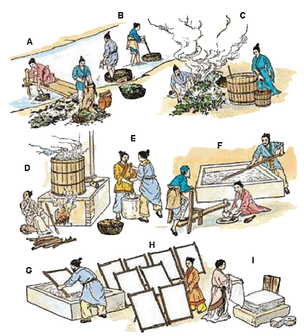

1. The image shows the process of this major development from the Song dynasty from start to finish. (7.3)
   1. Gun powder
   2. Dragon Backbone pump
   3. Creating new trade routes
   4. Papermaking
2. Which of the following were traded on the Silk Road? (7.6)
   1. Porcelain
   2. Religion
   3. Fabric
   4. All of the above
3. Which dynasty is most known for its advancements in agriculture, technology, and commerce? (7.3)
   1. Han C. Song
   2. Tang D. Ming
4. Which of the following would be an advancement for agricultural use during this era? (7.3)
   1. Tractor and plow
   2. New pumps for irrigation
   3. Decreasing available farmland
   4. Decrease in trade with other nations
5. Confucianism used elements of Kinship to establish both social and political hierarchy. Which of the following would NOT be an example of the hierarchy taught in Confucianism? (7.3)
6. Parent and Child
7. Friend and Foe
8. Ruler and Subject
9. Husband and Wife

Use the passage below to answer question 13.



1. Which of the following is best supported by the quote from Confucius? (7.3)
   1. If you wish for something hard enough it will just happen.
   2. If you work hard despite the challenges you will be rewarded.
   3. If you love everyone then good things will happen to you.
   4. Loving is easier to do than hating.

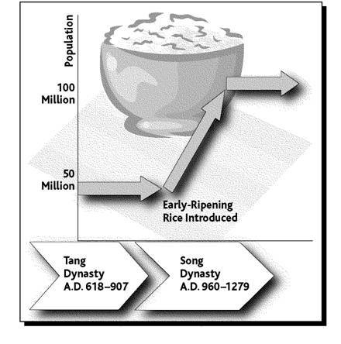

1. According to the graph, what was the population during the Tang dynasty? (7.3)

|  |  |  |
| --- | --- | --- |
|  | A. | 25 million |
|  | B. | 50 million |
|  | C. | 75 million |
|  | D. | 100 million |

1. What major development was introduced during the Song dynasty and what effect did it have on the population? (7.3)
   1. More farm land = population decrease
   2. More farm land = population increase
   3. Fast ripening rice = population decrease
   4. Fast ripening rice = population increase
2. Which of the following developments most affected the commercial (trade) growth during the Song dynasty? (7.22)
3. opening sea ports to foreign traders
4. compass
5. dragon backbone pump
6. moveable type blocks
7. What advantage did gunpowder provide to militaries? (7.22)
8. allowed for communication with fires
9. allowed for soldiers to attack from farther distances
10. allowed for soldiers to get closer to their opponents to fight
11. allowed for generals to plan better battle strategies

Use the map below to answer the following question.

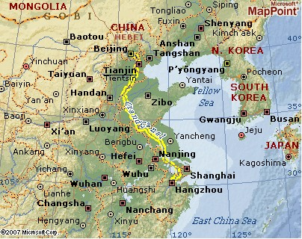

1. The Grand Canal was a major network of waterways that connected which two major rivers in China? (7.1)
   1. Yellow and Red C. Nile and Red
   2. Yangtze and Amazon D. Yellow and Yangtze
2. Which technologies spread from China to other parts of Asia, the Islamic world and Europe

on the Silk Road? (7.3)

1. paper making, wood-block printing, the magnetic compass, and gun powder
2. paper, printing press, the compass , and cannons
3. paper making, wood-block printing, magnetized needles, and cannons
4. paper making, wood-block printing, algebra, and gun powder

Use the map below to answer questions 22-24.

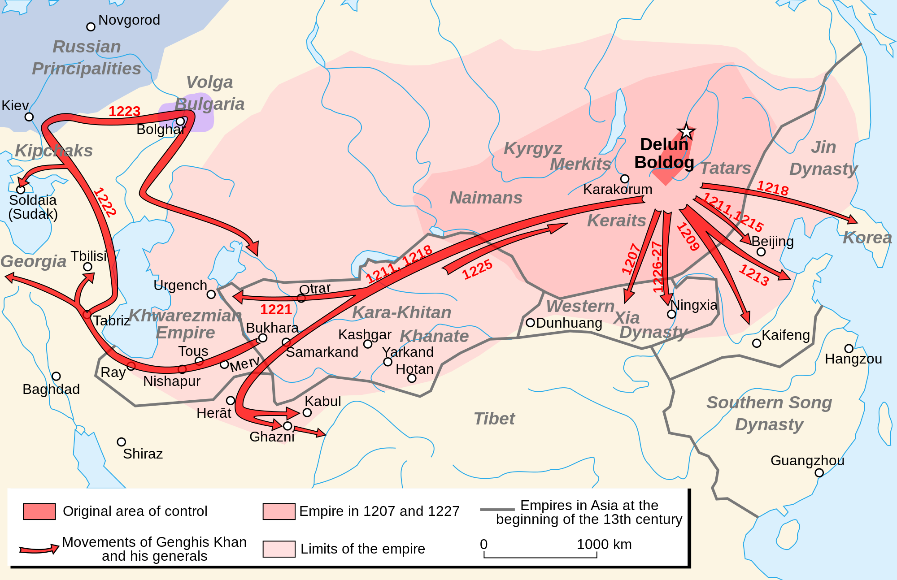

1. In what year did Genghis Khan move to Korea? (7.4)
2. 1213 C. 1207
3. 1218 D. 1221
4. What would be a good title for this map? (7.4)
5. The Silk Road
6. The Movements of Genghis Khan and his Generals
7. The Trans-Saharan Trade Route
8. The Empires of Asia

Use the passage below to answer question 25.

I am the grandson of Genghis Khan. I changed the focus of my people from military powerhouse and conquests to government and civic responsibility.

1. Who is described in the box to the above? (7.5)
2. Kublai Khan C. Confucius
3. Genghis Khan D. Buddha

Use the image below to answer questions 28-29.

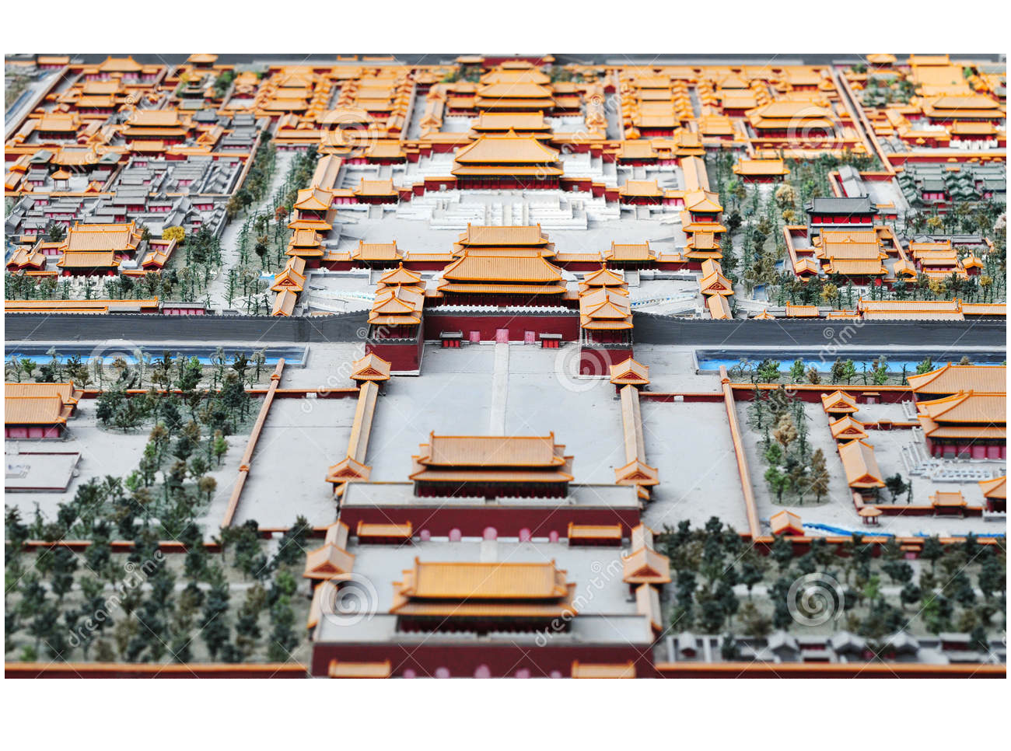

1. Name this contribution from the Ming Dynasty that housed the Chinese imperial [palace](http://en.wikipedia.org/wiki/Palace) and is located in the center of Beijing, China. (7.7)

A. The Forbidden City C. Beijing

B. The Great Wall of China D. Temple of Confucius

1. During the age of the Tang Dynasty the burning of coal at high temperatures led to the discovery of? (7.2)

A. Fire C. Steel

B. Crystals D. Iron

Use the image below to answer questions 30-31.

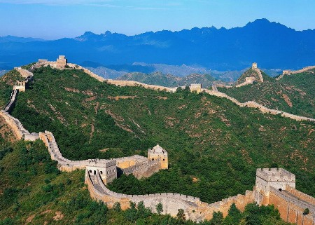

1. Identify the structure in the picture above and explain its **primary** purpose during the **Ming Dynasty**. (7.7)

A. Forbidden City: to keep people out of the city

B. Great Wall of China: to keep China isolated

C. Forbidden City: to keep the emperor isolated

D. Great Wall of China: to enhance the culture

1. Which answer best explains Marco Polo’s impact on China and Europe (7.6)

A. Marco Polo’s original plan was to visit China and return to Europe, but he loved China so much that he decided to move there.

B. Kublai Khan did not allow Marco Polo to enter the Yuan Dynasty so Polo returned to Europe knowing very little about Chinese culture.

C. Marco Polo spread the Chinese knowledge on scientific knowledge, medicine, and Algebra.

D. Marco Polo had a firsthand look at China working for Kublai Khan, and when he returned to Europe it created curiosity between Europe and China.

Use the graph below to answer question 32.

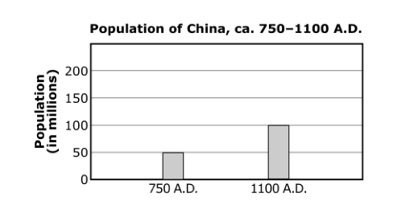

1. Which statement offers an explanation for how the Song Dynasty contributed to the change shown on the graph? (7.22)

A. Expanding territorial control to the Korean Peninsula increased the population of China significantly.

B. Improving agricultural techniques with irrigation and more productive strains of rice increased food

supplies.

C. Adopting government polices that led to respect for the family and ancestors resulted in increased

birthrates.

D. Adopting government policies that encouraged immigration from Central Asia caused people to move

to China.

Use the map below to answer questions 33-34.

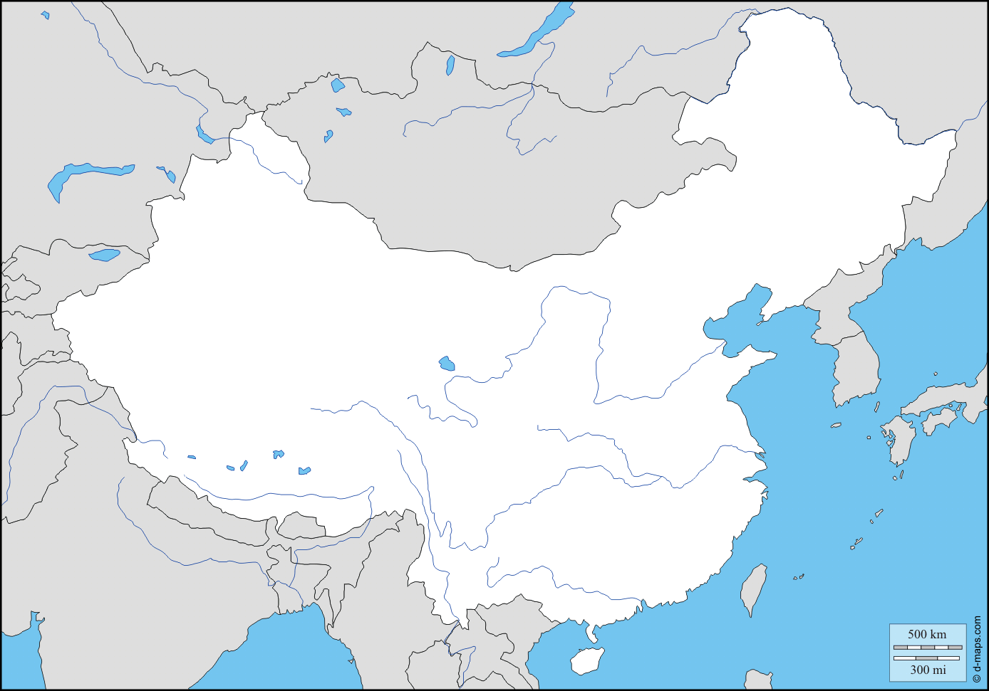

A

E

B

C

D

1. What body of water does letter C represent? (7.1)
2. Yellow River C. Han River
3. Yangtze River D. Amazon River
4. What landform does letter D represent? (7.19)
5. The Sahara Desert C. The Gobi Desert
6. The Plateau of Tibet D. Himalaya Mountains

Use the map below to answer question 35.

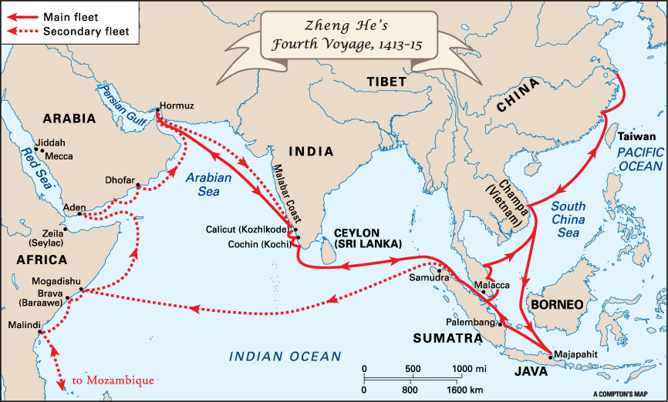

1. Zheng He, a Chinese Muslim, was a great explorer who went which of the following places (7.7)
   1. North & South America C. Japan & Korea
   2. Europe D. Southeast Asia, India, & East Africa